BUG 1
TITLE: - HOME PAGE LOGIN ERROR

DESCRITPION: -
When the user created a new account he is not able to login the application and access the homepage instead he is redirected to the login page even if he fills the details correctly.

REPLICATION: -
When we create a new account and try to login in the web page the page doesn’t show any response and tells us to refill our login details.

EXPECTED RESULT: -
When a new user is joined he should immediately be able to access his account .

ACTUAL RESULT: -
The new user is not able to join immediately after login.
PRIORITY: - HIGH. SEVERITY: - HIGH.

ATTACHED DOCUMENT

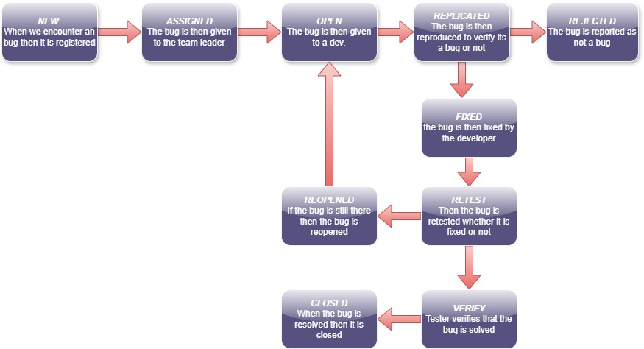

BUG 2

TITLE: - CONTENT OF HOME PAGE IS NOT SHOWING
DESCRIPTION: -
When the user enters his home page he can only access a single page he is not able to perform any further actions or can access any other information

REPLICATION: -
When we load our main home page only the firstpage is accessible other pages cant be accessed also no other action can be done in the home page

EXPECTED RESULT: -
When we are on the home page we should be able to access any page at any time and perform certain action

ACTUAL RESULT: -
When we are on homepage we are only able to acces first page and can’t perform any action
PRIORITY: - HIGH SEVERITY: - HIGH

BUG 3

TITLE: - THE WRITTEN PASSOWARD CAN’T BE UNDONE

DESCRIPTION: -
When the user writes any incorrect word in his password he is not able to remove or undo it he has to restart the whole password

DUPLICATE: -
When he open our page then fill our account password if we mistakenly type any wrong word we are not able to remove or erase that single word we have to restart the whole page

EXPECTED RESULT: -
We should be able to clear any mistakenly written word in our password

ACTUAL RESULT: -
We are not able to clear any single word from the password
PRIORITY: - LOW

SEVERITY: - LOW

